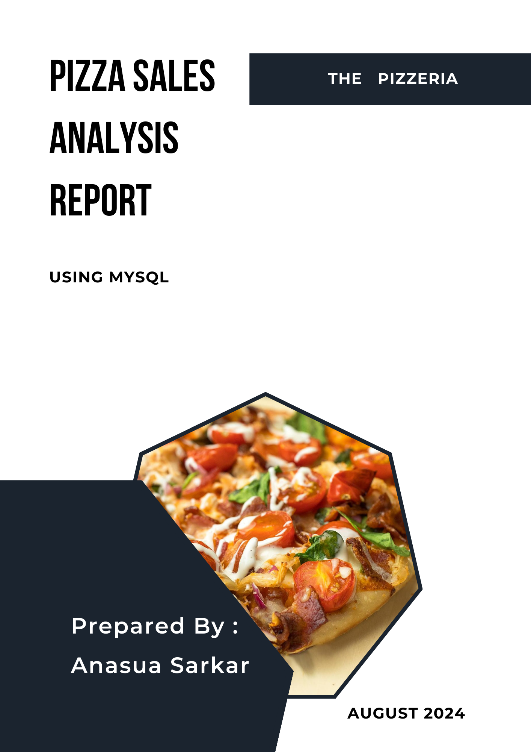

Introduction

In the competitive food industry, data-driven decision-making is essential for businesses to stay ahead. This project analyses pizza sales data to uncover valuable insights that can enhance a pizzeria's operational efficiency and profitability. By examining various aspects of sales, such as order frequency, revenue generation, and customer preferences, this analysis will provide a detailed understanding of the factors driving sales performance.

The project is structured into three levels of analysis: Basic, Intermediate, and Advanced. The Basic analysis addresses foundational questions such as total orders, revenue, and popular pizza types. The Intermediate analysis delves deeper into sales patterns, including hourly order distribution and category-wise pizza preferences. Finally, the Advanced analysis provides a more granular view of revenue contributions and the performance of pizza types within specific categories. Through this structured approach, the project aims to equip stakeholders with actionable insights that can guide menu optimisation, marketing strategies, and operational improvements, ultimately driving the business toward greater success.

Problem statement

The primary goal of this project is to conduct a comprehensive analysis of pizza sales data to gain insights into customer preferences, sales trends, and revenue generation. By leveraging SQL queries in MySQL, the project aims to address key questions that can inform business decisions, such as understanding which pizzas are most popular, identifying peak sales periods, and analyzing the revenue contribution of different pizza types. The insights derived from this analysis will help the business optimize its menu offerings, pricing strategy, and marketing efforts to maximize profitability and customer satisfaction.

Project Objectives:

The primary objectives of this project are to analyse the pizza sales data to achieve the following:

* Understand the overall sales performance and revenue generation.
* Identify customer preferences in terms of pizza types and sizes.
* Determine the distribution of sales over different times and categories.
* Analyse revenue contributions of various pizza types and categories.

Analysis Questions:

To achieve these objectives, the following specific questions will be addressed:

Basic Analysis:

1. Order Volume: What is the total number of orders placed? Revenue Calculation: How much total revenue has been generated from pizza sales?
2. Pricing Insight: Which pizza is the highest-priced?
3. Size Popularity: What is the most commonly ordered pizza size?
4. Top Pizza Types: Which are the top 5 most ordered pizza types and their respective quantities

Intermediate Analysis:

1. Category-Wise Sales: What is the total quantity of each pizza category ordered?
2. Hourly Sales Distribution: How are orders distributed by the hour of the day?
3. Category Distribution: How do pizza orders distribute across different categories?
4. Daily Order Trends: What is the average number of pizzas ordered per day, grouped by date?
5. Top Pizza Revenue: Which are the top 3 most ordered pizza types based on revenue.

Advanced Analysis:

1. Revenue Contribution: What is the percentage contribution of each pizza type to total revenue?
2. Cumulative Revenue: How has the cumulative revenue generated from pizza sales evolved over time?
3. Category-Specific Top Pizzas: What are the top 3 most ordered pizza types based on revenue within each pizza category?

Setting Up the Database for Pizza Sales Analysis

In this project, I initiated the process of analyzing pizza sales by setting up a MySQL database to store and organize the relevant data. The steps taken are as follows:

**1. Creating the Database**:

I started by creating a new database named PIZZERIA to hold all the tables and data required for the analysis.



**2.Verifying Data Import:**

After importing the data, I performed an initial check by selecting all records from the pizzas and pizza_types tables to ensure that the data was correctly loaded.

3.Creating the orders Table:

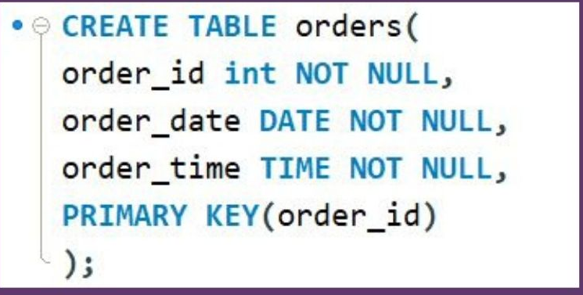Next, I created a table named orders to store details of each pizza order. This table includes columns for order_id, order_date, and order_time. The order_id column is set as the primary key to uniquely identify each order.

5 Oreating the order_details Table:

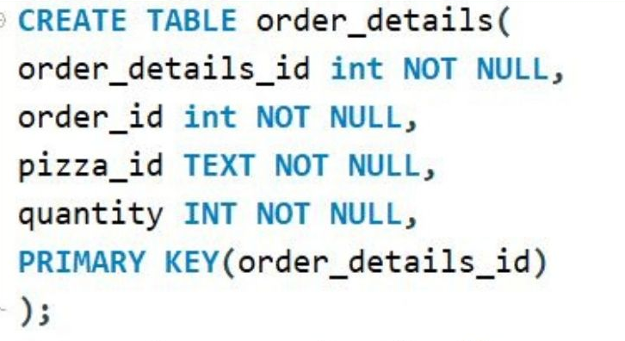

To capture the details of each order, I created the order_details table. This table stores information such as order_details_id, order_id, pizza_id, and quantity. The order_details_id is the primary key, ensuring each record is unique, while order_id acts as a foreign key to link to the orders table

5. Verification of Data Structure:

Finally, I verified the structure of the order_details and orders table by selecting all its records to ensure that ,the tables are correctly created and ready to store the data.



Basic Analysis

1. Order Volume: What is the total number of orders placed? Revenue Calculation: How much total revenue has been generated from pizza sales?



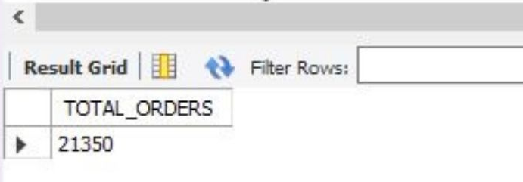

Total Order: 21350

1. Calculate the total revenue generated from pizza sales.

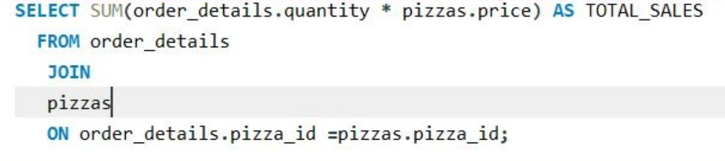

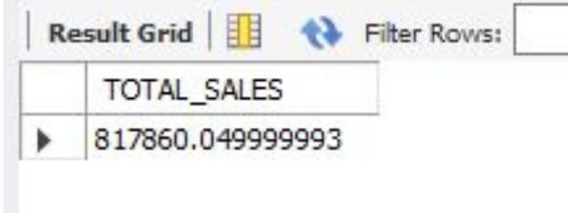

Total Revenue: 817860 pounds

1. Pricing Insight: Which pizza is the highest-priced?

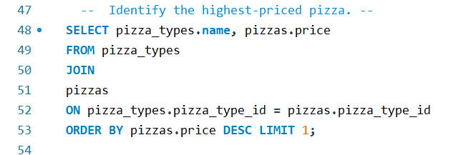

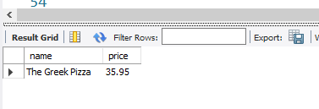

The highest priced pizza is:”The Greek Pizza”

1. Size Popularity: What is the most commonly ordered pizza size?

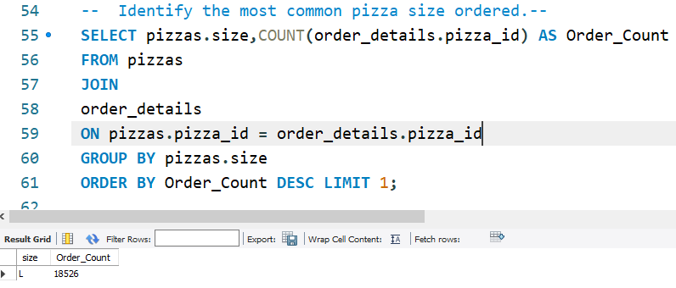

Most popular pizza size is “Large”

5. Top Pizza Types: Which are the top 5 most ordered pizza types and their respective quantities

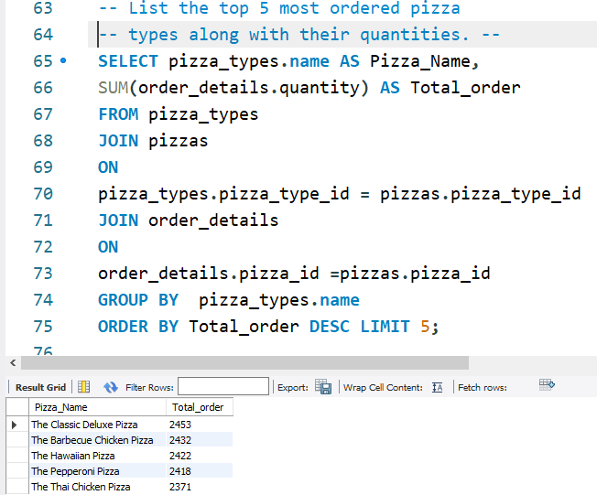

The top five pizza type ordered is-

First is “The Classic Deluxe Pizza” with total number of order - 2453 pizzas.

Second “The Barbecue Chicken Pizza” with total number of order - 2432 pizzas.

Third “The Hawaiian Pizza” with total number of order - 2422 pizzas.

Fourth “The Pepperoni Pizza” with total number of order - 2418 pizzas.

Fifth “The Thai chicken Pizza” with total number of order - 2371 pizzas.

List Ordered Pizzas

The list orderd pizzas are –

The Brie Carre Pizza with 490 orders only, The Mediterran Pizza with 934 orders only, The Calabrese Pizza with 937 orders only, The Spinach Supreme Pizza with 950 orders onl and The Soppressat Pizza with 961 orders only.

Intermediate Analysis

1. What is the total quantity of each pizza category ordered?

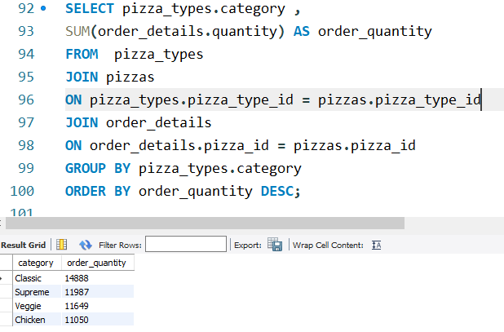

2. How are orders distributed by the hour of the day? 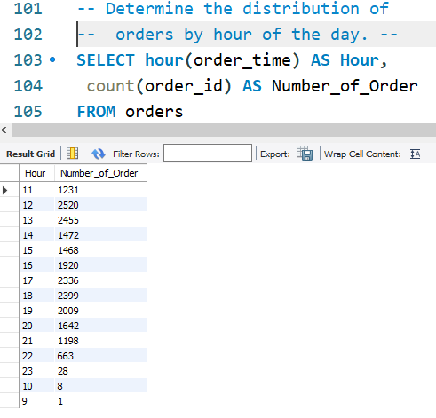

The busiest hours of the day are 12 pm to 2pm in the afternoon and 4 pm to 9pm.

1. Category Distribution: How do pizza orders distribute across different categories?

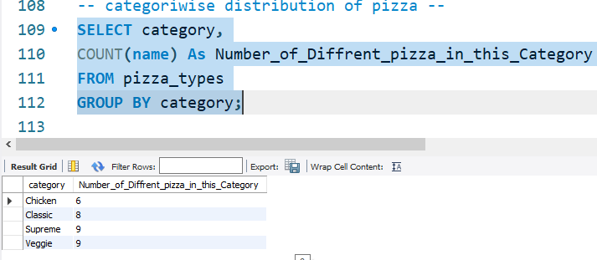

2. Daily Order Trends: What is the average number of pizzas ordered per day, grouped by date?

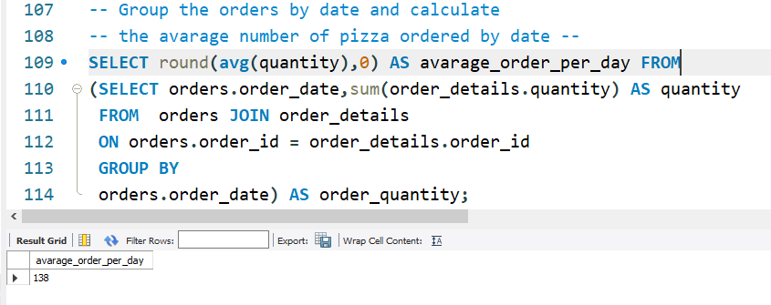

Average Per day order is 138.

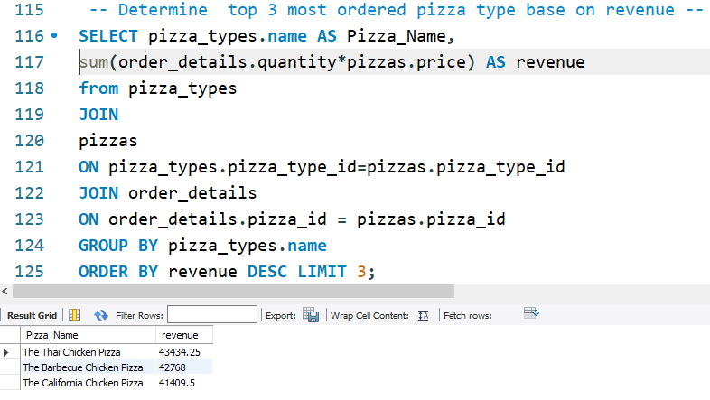3. Pizza Revenue: Which are the top 3 most ordered pizza types based on revenue.

Top three revenue generating pizza is

1. The Thai Chicken Pizza
2. The Barbecue Chicken Pizza
3. The California Chicken Pizza

Advanced Analysis:

1. Revenue Contribution: What is the percentage contribution of each pizza type to total revenue?

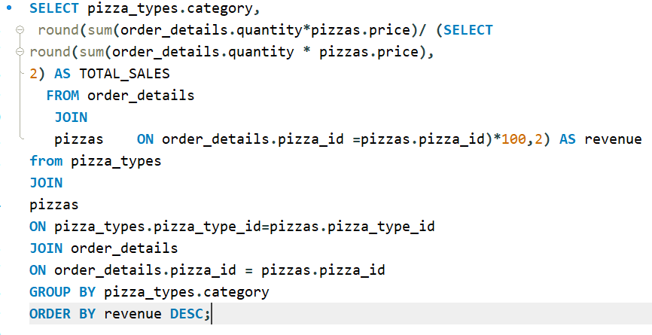

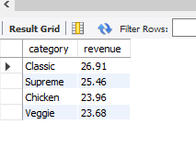

2. Cumulative Revenue: How has the cumulative revenue generated from pizza sales evolved over time?

Step -1

Revenue by day:

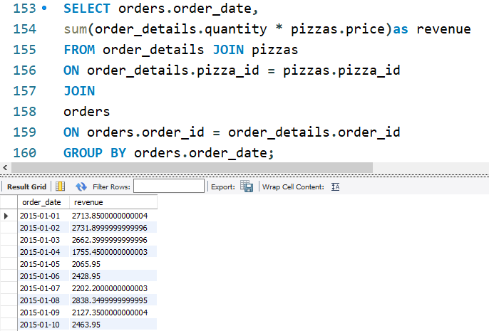

Step -2

Cumulative Revenue:

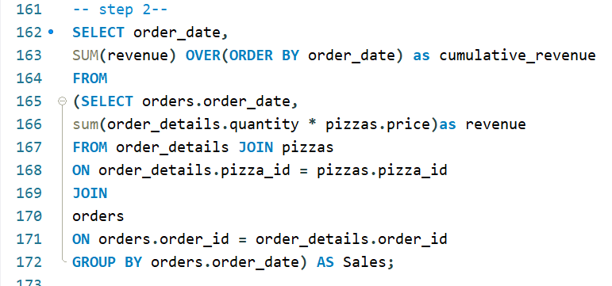

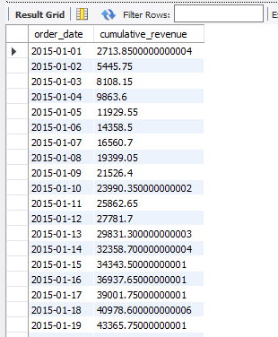

The cumulative revenue data tracks the total revenue generated by the business over a specific period. This metric is crucial for understanding the overall financial performance and growth trajectory of the business.

The data indicates a consistent increase in cumulative revenue over the specified period. This upward trend suggests a steady flow of sales, which is a positive sign for the business's financial health.

1. Category-Specific Top Pizzas: What are the top 3 most ordered pizza types based on revenue within each pizza category?

Step-1: **Calculating Revenue for Each Pizza Type**

In this step, the revenue for each pizza type was calculated by summing the product of the quantity ordered and the price of each pizza. This was done for each pizza type within its respective category. The SQL query for this step is as follows:

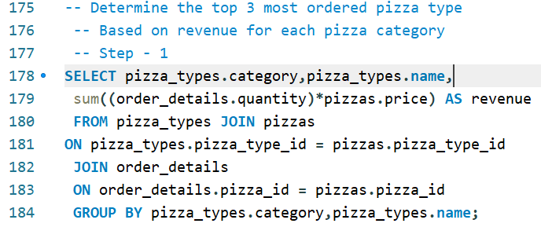

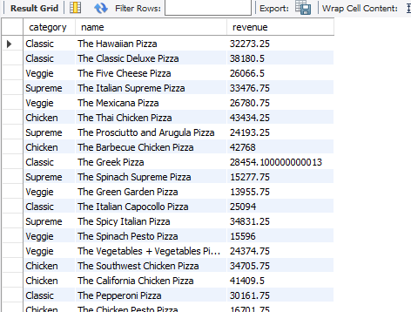

Step-2: **Ranking Pizzas by Revenue Within Each Category**

After calculating the revenue, pizzas were ranked within their categories based on the revenue generated. This was done using the RANK() function, which assigns a rank to each pizza type within its category according to its revenue. The SQL query for this step is:

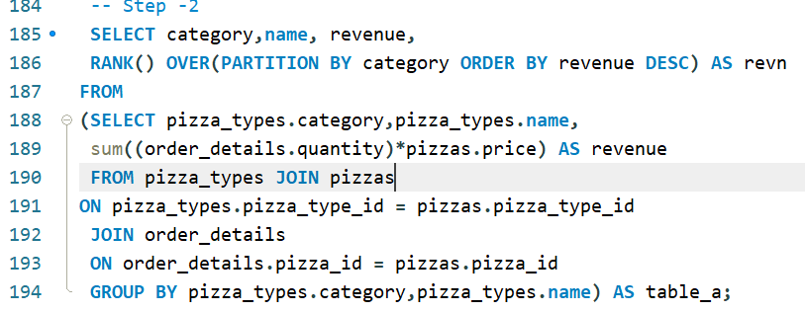

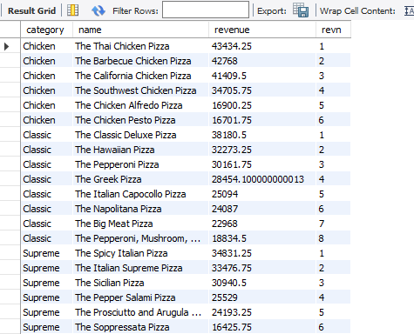

Step: 3: **Selecting the Top 3 Pizzas per Category**

Finally, the top 3 pizzas in terms of revenue for each category were selected. This step filtered the ranked pizzas to include only those with a rank of 1, 2, or 3. The SQL query used is:

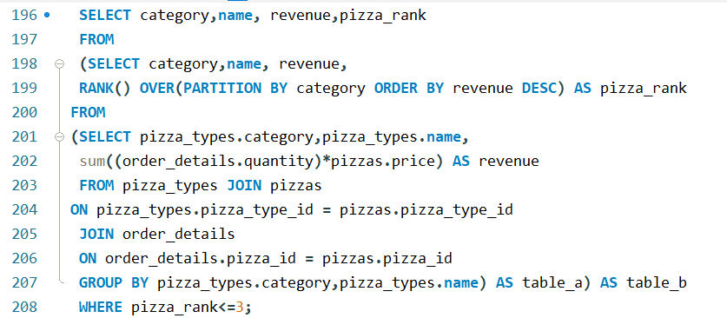

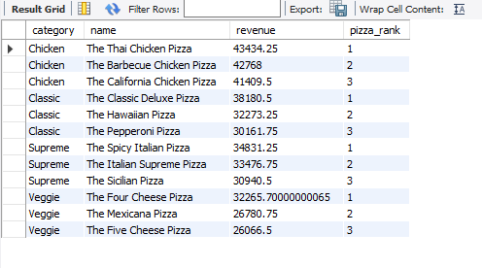

The query successfully returned the top 3 most ordered pizza types based on revenue for each category. These results can now be used to gain insights into which pizzas are driving the most revenue and could help in making informed business decisions such as menu adjustments, targeted promotions, or inventory prioritization.

The analysis identified the top 3 most ordered pizza types based on revenue for each category. Below is a summary of the findings:

Chicken Category:

1. The Thai Chicken Pizza - $43,434.25

2. The Barbecue Chicken Pizza - $42,768.00

3. The California Chicken Pizza - $41,409.50

Classic Category:

1. The Classic Deluxe Pizza - $38,180.50

2. The Hawaiian Pizza - $32,273.25

3. The Pepperoni Pizza - $30,161.75

Supreme Category:

1. The Spicy Italian Pizza - $34,831.25

2. The Italian Supreme Pizza - $33,476.75

3. The Sicilian Pizza - $30,940.50

Veggie Category:

1. The Four Cheese Pizza - $32,265.70

2. The Mexicana Pizza - $26,780.75

3. The Five Cheese Pizza - $26,066.50

Explanation

The results show that each category has a distinct set of top performers. For example, in the Chicken category, The Thai Chicken Pizza leads with the highest revenue, followed closely by The Barbecue Chicken Pizza and The California Chicken Pizza. Similarly, in the Classic category, The Classic Deluxe Pizza generates the most revenue, while in the Supreme category, The Spicy Italian Pizza ranks first. For the Veggie category, The Four Cheese Pizza is the top-seller.

The query successfully returned the top 3 most ordered pizza types based on revenue for each category. These results can now be used to gain insights into which pizzas are driving the most revenue and could help in making informed business decisions such as menu adjustments, targeted promotions, or inventory prioritization.

**Conclusion**

The pizzeria sales analysis provided insightful data that can significantly inform business strategies and decision-making processes.

Order Volume & Revenue: The pizzeria has achieved a substantial total order volume of 21,350 orders, resulting in total revenue of £817,860. These figures demonstrate a strong market demand and effective sales strategies.

Top Performers: The analysis revealed that "The Greek Pizza" is the highest-priced item on the menu, while "The Classic Deluxe Pizza" is the most popular, with 2,453 orders. Additionally, the "Large" size is the most commonly ordered, indicating customer preference for larger portions. The top five pizzas, led by "The Classic Deluxe Pizza," collectively dominate the menu, highlighting key products that drive sales.

Category Insights: The sales data indicates a fairly balanced distribution across different pizza categories, with the "Classic" category leading in total orders (14,888 pizzas). The chicken-based pizzas, particularly "The Thai Chicken Pizza," have emerged as significant contributors to revenue, underlining the popularity of this flavor profile among customers.

Hourly and Daily Trends: Peak order times were identified between 12 PM to 2 PM and 4 PM to 9 PM, aligning with typical lunch and dinner hours. The average daily order volume stands at 138, providing a baseline for operational planning and staffing.

Revenue Contribution: Each pizza category contributes significantly to the total revenue, with "Classic" pizzas contributing the most (26.91%), followed closely by "Supreme," "Chicken," and "Veggie" categories. This distribution suggests that while all categories are important, focusing on the top-performing categories could yield greater financial benefits.

**Strategic Implications**

The findings highlight the need to possibly prioritize inventory for top-selling pizzas and consider promotional strategies for the less popular ones. Additionally, the distinct peak order hours suggest a targeted approach in staffing and resource allocation during these times to optimize customer service and operational efficiency.

# Final Thoughts

This analysis has provided a clear picture of the pizzeria’s sales dynamics, revealing both strengths and opportunities for growth. By leveraging these insights, the pizzeria can enhance its product offerings, optimize operations, and ultimately increase profitability.